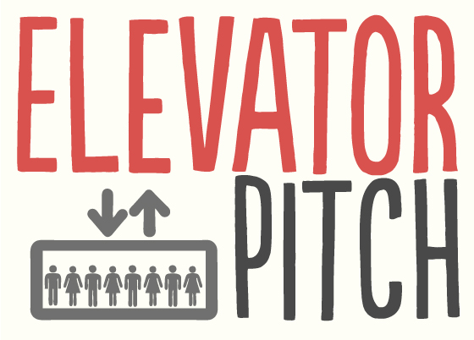
PREPARATION
Look at this website and choose your favourite website – explain it to the group.
https://www.simplemarketingnow.com/blog/flooring-the-consumer/bid/168520/what-great-brands-do-with-mission-statements-8-examples
NOW THINK ABOUT YOUR OWN IDEA
- What are you going to present? Idea / company / project / yourself
We are going to present “Josep Lajara”. He’s one of our teammates

- Write some ideas for the following sections:- (NOTE FORM – adjectives, reasons explanations)

- Who I am
I’m an operating system, actually the best for programmers.
- What I do
I make the programing tools easier to use and manage
I’m more secure than the other OS(Operating system)

- Mission statement (write in 140 characters – TWEET PITCH)
_ _ _ _ _ _ _ _ _ _ _ _ _ _ _ _ _ _ _ _ _ _ _ _ _ _ _ _ _ _ _ _ _ _ _ _ _ _ _ _
_ _ _ _ _ _ _ _ _ _ _ _ _ _ _ _ _ _ _ _ _ _ _ _ _ _ _ _ _ _ _ _ _ _ _ _ _ _ _ _
_ _ _ _ _ _ _ _ _ _ _ _ _ _ _ _ _ _ _ _ _ _ _ _ _ _ _ _ _ _ _ _ _ _ _ _ _ _ _ _
_ _ _ _ _ _ _ _ _ _ _ _ _ _ _ _ _ _ _ _

- Hook

- Final contact info

USEFUL PHRASES

Signposting
Section of presentation | Signpost language
Introducing the topic | The subject/topic of my talk is ...  I'm going to talk about ...
Overview (outline of presentation) | I’m going to divide this talk into four parts.  Basically/ Briefly, I have three things to say.  I'd like to begin/start by ...  Let's begin/start by ...  First of all, I'll...  … and then I’ll go on to …  Then/ Next ...  Finally/ Lastly ...
Finishing a section | That's all I have to say about...  We've looked at...  So much for...
Starting a new section | Moving on now to …  The next issue/topic/area I’d like to focus on …  Now we'll move on to...
Analysing a point and giving recommendations | Let's consider this in more detail...  What does this mean for...?  Why is this important?  The significance of this is...
Giving examples | A good example of this is...  As an illustration,...  To illustrate this point...
Summarising and concluding | To sum up ...  To summarise...  In conclusion ...  In short ...
Paraphrasing and clarifying | Simply put...  In other words.......  So what I’m saying is....  To put it another way....
Invitation to discuss / ask questions | I’m happy to answer any queries/ questions.  Does anyone have any questions or comments?  Please feel free to ask questions.

